PROJECT REPORT

ON

INTELLIGENT STREET LIGHTING SYSTEM

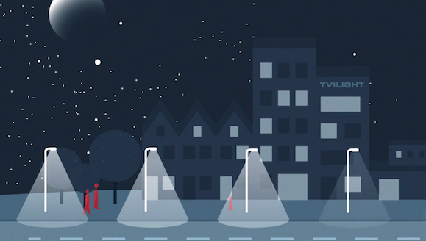

# INTELLIGENT STREET LIGHTING SYSTEM

# **Design and construction of energy efficient intelligent street light system**

### Abstract

The issue of energy efficiency is very paramount for every field. Growing technologies and use of these technologies in every field are creating a large problem for energy management. The amount of power consumption of some electronic machineries cannot be eliminated for example a security system should work 24 hours. but it not true for all the devices ,as a street lights need not to work all day long they should function during night and that to in the presence of any movement Generally, street lights are switched on for whole night and during the day, they are switched off. But during the night time, street lights are not necessary if there is no traffic. Saving of this energy is very important factor these days as energy resources are getting reduced day by day. Alternatives for natural resources are very less and our next generations may face lot of problems because of lack of these natural resources. Hence, intelligent street light system enables us to save power in several methods ,as it runs of solar as well as mains supply so it consumes less energy from mains as it automatically shifts from solar to mains depending on the battery conditions ,it senses day time and night time so that the light can be activated during night only , it senses the presences of movement so that if anything is present on the road then it will automatically turn on the street light and turn it off in the absence of movement, all the status of system is being printed on serial monitor i.e LDR reading ,solar to main shift ,movement sensing plus any fault detected during the functioning of the system ,which serve a easy monitoring of the system in this manner a intelligent street light system saves a considerable amount of energy for further use . street lights are the most important feature of road safety hence this technology is inventible , and adding above mentioned features makes it more efficient .the use of microcontroller ,PIR ,LDR and some other electronic devises coupled together to accomplish the project .from this project we hope to build a energy efficient street light system.

## Introduction: Project Overview and Objectives

Intelligent streetlight system is a efficient way for using energy, as it takes power from solar charged battery and from the main supply. When the solar battery is less than 10% it automatically shift to the main supply and as the charge boost to 100 again it shift back to the solar supply. For further saving of energy PIR and LDR are used to make it more efficient as PIR sense the presence of vehicle so when a vehicle passes from the range of sensor it commands the street light to switch on ,and in the absence of vehicle movement the street lights are switched off to save power consumption .by the use of LDR it sense daytime or night time so that the street light will only work during night . in this manner a intelligent street light system saves a considerable amount of energy for further use The issue of energy efficiency is very paramount for every field . Growing technologies and use of these technologies in every field are creating a large problem for energy conservation. The amount of power consumption of some electronic machineries cannot be eliminated for example a security system should work 24 hours. but it not true for all the devices, as a street lights need not to work all day long they should function during night and that to in the presence of any movement. all the status of system is being printed on serial monitor i.e LDR reading ,solar to main shift ,movement sensing plus any fault detected during the functioning of the system ,which serve a easy monitoring of the system .intelligent street light system enables us to save power in several methods mentioned above street lights are the most important feature of road safety hence this technology is inventible, and adding above mentioned features makes it more efficient.

**Modelling approach**

To meet the demands of the various functionality of the project different approaches has been tried out .To have a automatic day and night switching system the team went for opting LDR as works on the principal of variation in resistance with the varying intensity of light ,this changed value of resistance triggers the switching mechanism , and for detecting movement we opt for PIR sensors as they work on the infrared radiation which is a result of temperature above absolute zero, for alternative power source we went for solar energy as it is more efficient and easily available than others the linking between solar and mains totally depends on the coding .The final product is a combination of code linking various independent circuits together of the street light .

**Report organization**

This report is structured as follows, after this introductory chapter, chapter 2 discusses the development of the integrated model and its component chapter 3 describes the implementations of the model chapter 4 provides the conclusion for the project and directions for further research

## Development of the model: Components overview

This project is able to perform various task like shifting of power source, sensing movement and daytime or nighttime for all these various functionality product needs several components integrated together to give the final complete product , components used in this project are described below.

**1. PIR sensor (Passive Infrared sensor)**

A passive infrared sensor (PIR sensor) is an electronic sensor that measures infrared (IR) light radiating from objects in its field of view. They are most often used in PIR-based motion detectors.

**Operating principle**

All objects with a temperature above absolute zero emit heat energy in the form of radiation. Usually this radiation isn't visible to the human eye because it radiates at infrared wavelengths, but it can be detected by electronic devices designed for such a purpose. The term passive in this instance refers to the fact that PIR devices do not generate or radiate energy for detection purposes. They work entirely by detecting infrared radiation emitted by or reflected from objects. They do not detect or measure "heat".

**Product design**

The PIR sensor is typically mounted on a printed circuit board containing the necessary electronics required to interpret the signals from the sensor itself. The complete assembly is usually contained within a housing, mounted in a location where the sensor can cover area to be monitored. The housing will usually have a plastic "window" through which the infrared energy can enter. Despite often being only translucent to visible light, infrared energy is able to reach the sensor through the window because the plastic used is transparent to infrared radiation. The plastic window reduces the chance of foreign objects (dust, insects, etc.) from obscuring the sensor's field of view, damaging the mechanism, and/or causing false alarms. The window may be used as a filter, to limit the wavelengths to 8-14 micrometer, which is closest to the infrared radiation emitted by humans. It may also serve as a focusing mechanism.

**Application**

Generally, street lights are switched on for whole night and during the day, they are switched off. But during the night time, street lights are not necessary if there is no traffic. Saving of this energy is very important factor these days as energy resources are getting reduced day by day. Alternatives for natural resources are very less and our next generations may face lot of problems because of lack of these natural resources.

**3. LDR (Light Dependent Resistor)**

A photo resistor (or light-dependent resistor, LDR, or photo-conductive cell) is a light-controlled variable resistor.

**Operating principle**

The resistance of a photoresist or decreases with increasing incident light intensity; in other words, it exhibits photoconductivity. A photo resistor can be applied in light-sensitive detector circuits, and light-activated and dark-activated switching circuits.

**Product design**

A photoresist or is made of a high resistance semiconductor. In the dark, a photo resistor can have a resistance as high as several mega ohms (MΩ), while in the light, a photoresist or can have a resistance as low as a few hundred ohms. If incident light on a photo resistor exceeds a certain frequency, photons absorbed by the semiconductor give bound electrons enough energy to jump into the conduction band. The resulting free electrons (and their hole partners) conduct electricity, thereby lowering resistance. The resistance range and sensitivity of a photoresist or can substantially differ among dissimilar devices. Moreover, unique photoresists may react substantially differently to photons within certain wavelength bands.

A photoelectric device can be either intrinsic or extrinsic. An intrinsic semiconductor has its own charge carriers and is not an efficient semiconductor, for example, silicon. In intrinsic devices the only available electrons are in the valence band, and hence the photon must have enough energy to excite the electron across the entire band gap. Extrinsic devices have impurities, also called dopants, added whose ground state energy is closer to the conduction band; since the electrons do not have as far to jump, lower energy photons (that is, longer wavelengths and lower frequencies) are sufficient to trigger the device. If a sample of silicon has some of its atoms replaced by phosphorus atoms (impurities), there will be extra electrons available for conduction. This is an example of an extrinsic semiconductor.

**Application**

Photoresists come in many types. Inexpensive cadmium sulfide cells can be found in many consumer items such as camera light meters, clock radios, alarm devices (as the detector for a light beam), nightlights, outdoor clocks, solar street lamps and solar road studs, etc. Photoresists can be placed in streetlights to control when the light is on. Ambient light falling on the photoresist or causes the streetlight to turn off. Thus energy is saved by ensuring the light is only on during hours of darkness.

**4. SOLAR panel**

Photovoltaic solar panels absorb sunlight as a source of energy to generate electricity. Photovoltaic modules constitute the photovoltaic array of a photovoltaic system that generates and supplies solar electricity in commercial and residential applications.

**Operating principle**

Photovoltaic modules, commonly called solar modules, are the key components used to convert sunlight into electricity. Solar modules are made of semiconductors that are very similar to those used to create integrated circuits for electronic equipment. The most common type of semiconductor currently in use is made of silicon crystal. Silicon crystals are laminated into n-type and p-type layers, stacked on top of each other. Light striking the crystals induces the “photovoltaic effect,” which generates electricity. The electricity produced is called direct current (DC) and can be used immediately or stored in a battery. For systems installed on homes served by a utility grid, a device called an inverter changes the electricity into alternating current (AC), the standard power used in residential homes.

**Product design**

High purity silicon crystals are used to manufacture solar cells. The crystals are processed into solar cells using the melt and cast method. The cube-shaped casting is then cut into ingots, and then sliced into very thin wafers.

Silicon atoms have four "arms." Under stable conditions, they become perfect insulators. By combining a small number of five-armed atoms (with a surplus electron), a negative charge will occur when sunlight (photons) hits the surplus electron. The electron is then discharged from the arm to move around freely. Silicon with these characteristics conducts electricity. This is called an n-type (negative) semiconductor, and is usually caused by having the silicon 'doped' with a phosphorous film. In contrast, combining three-armed atoms that lack one electron results in a hole with an electron missing. The semiconductor will then carry a positive charge. This is called a p-type (positive) semiconductor, and is usually obtained when boron is doped into the silicon.

A p-n junction is formed by placing p-type and n-type semiconductors next to one another. The p-type, with one less electron, attracts the surplus electron from the n-type to stabilize itself. Thus the electricity is displaced and generates a flow of electrons, otherwise known as electricity.

When sunlight hits the semiconductor, an electron springs up and is attracted toward the n-type semiconductor. This causes more negatives in the n-type semiconductors and more positives in the p-type, thus generating a higher flow of electricity. This is the photovoltaic effect.

**Application**

The most common application of solar panels is solar water heating systems.The price of solar power has continued to fall so that in many countries it is cheaper than ordinary fossil fuel electricity from the electricity grid, a phenomenon known as grid parity.

**4. Arduino**

Arduino is an open source computer hardware and software company, project, and user community that designs and manufactures single-board microcontrollers and microcontroller kits for building digital devices and interactive objects that can sense and control objects in the physical and digital world. The project's products are distributed as open-source hardware and software, which are licensed under the GNU Lesser General Public License (LGPL) or the GNU General Public License (GPL), permitting the manufacture of Arduino boards and software distribution by anyone. Arduino boards are available commercially in preassembled form, or as do-it-yourself (DIY) kits.

## Final project: Project explanation

This chapter contains the total overview of the project it contains the circuit diagram ,working and the code of the system

**Circuit diagram**

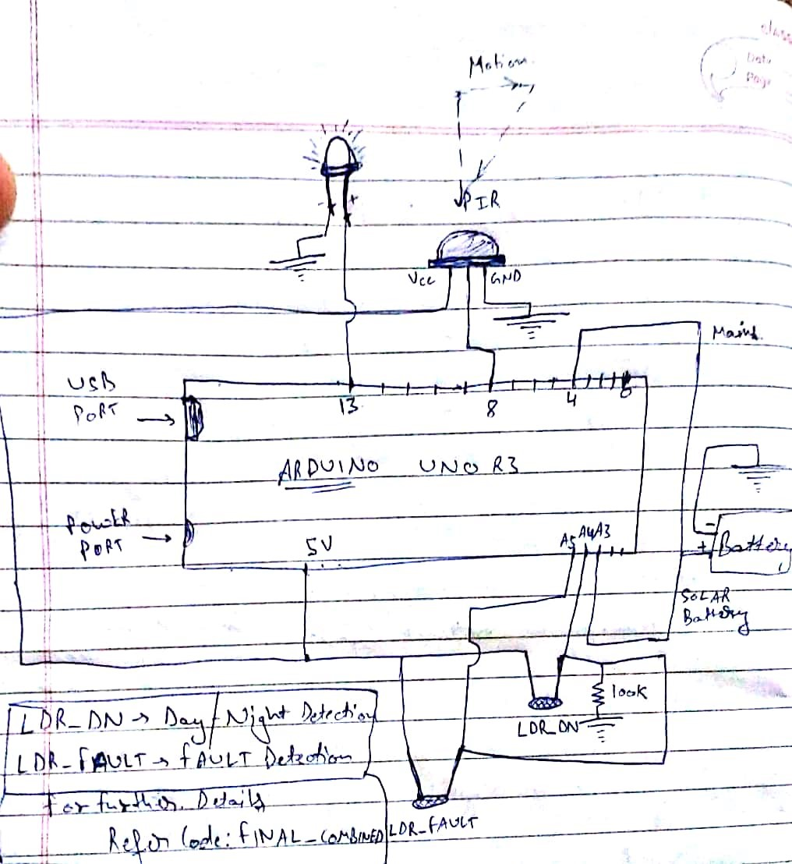

Working

Solar battery takes its power from solar panel which have Photovoltaic modules, commonly called solar modules, are the key components used to convert sunlight into electricity. Solar modules are made of semiconductors that are very similar to those used to create integrated circuits for electronic equipment. The most common type of semiconductor currently in use is made of silicon crystal. Silicon crystals are laminated into n-type and p-type layers, stacked on top of each other. Light striking the crystals induces the “photovoltaic effect,” which generates electricity. The electricity produced is called direct current (DC) and can be used immediately or stored in a battery. For systems installed on homes served by a utility grid, a device called an inverter changes the electricity into alternating current (AC), and the terminals of the solar battery is connected to the analog pin 2 and ground pin of the ardiuno UNO board ,until the pin A2 is having supply from solar is more than 10 % it works as the energy source for the system when pin A2 gives the the signal of less than 10 % the microcontroller shifts the supply to the digital pin 4 where the mains is connected, when the solar battery is again charged to the 100 the microcontroller again shifts the supply to the solar system and now the system takes the supply from the mains ,motion detection is done by passive IR sensor which have three terminals VCC,GND and output terminal this output terminal is connected to the digital pin 8 it works is to produce a signal when motion is detected and motion detection works on a principal that is .All objects with a temperature above absolute zero emit heat energy in the form of radiation. Usually this radiation isn't visible to the human eye because it radiates at infrared wavelengths, but it can be detected by electronic devices designed for such a purpose. The term passive in this instance refers to the fact that PIR devices do not generate or radiate energy for detection purposes. They work entirely by detecting infrared radiation emitted by or reflected from objects. They do not detect or measure "heat". if sensor detects any movement than the signal is send to the pin 8 ,when microcontroller senses signal at pin 8 it activates the street light configuration ,for day and night detection LDR is given a 5v supply from the ardiuno board whenever daylight falls on the sensors of LDR the resistance of a photo resistor decreases with increasing incident light intensity; in other words, it exhibits photoconductivity. A photo resistor can be applied in light-sensitive detector circuits, and light-activated and dark-activated switching circuits. and the detected output comes at the analog pin A1 ,when A1 is high the microcontroller switch on the street light configuration which is connected in series with a voltage booster at digital pin 13.

## Conclusions

All the features of street light makes its energy efficient as the issue of energy efficiency is very paramount for every field. Growing technologies and use of these technologies in every field are creating a large problem for energy management. The amount of power consumption of some electronic machineries cannot be eliminated for example a security system should work 24 hours. but it not true for all the devices ,as a street lights need not to work all day long they should function during night and that to in the presence of any movement Generally, street lights are switched on for whole night and during the day, they are switched off. But during the night time, street lights are not necessary if there is no traffic. Saving of this energy is very important factor these days as energy resources are getting reduced day by day. Alternatives for natural resources are very less and our next generations may face lot of problems because of lack of these natural resources. Hence, intelligent street light system enables us to save power in several methods ,as it runs of solar as well as mains supply so it consumes less energy from mains as it automatically shifts from solar to mains depending on the battery conditions ,it senses day time and night time so that the light can be activated during night only , it senses the presences of movement so that if anything is present on the road then it will automatically turn on the street light and turn it off in the absence of movement .in this manner a intelligent street light system saves a considerable amount of energy for further use . street lights are the most important feature of road safety hence this technology is inventible , and adding above mentioned features makes it more efficient .the use of microcontroller ,PIR ,LDR and some other electronic devises coupled together to accomplish the project .from this project we hope to build a energy efficient street light system.

Hence, our intelligent street light system makes street lights more efficient and productive in the field of energy conservation.